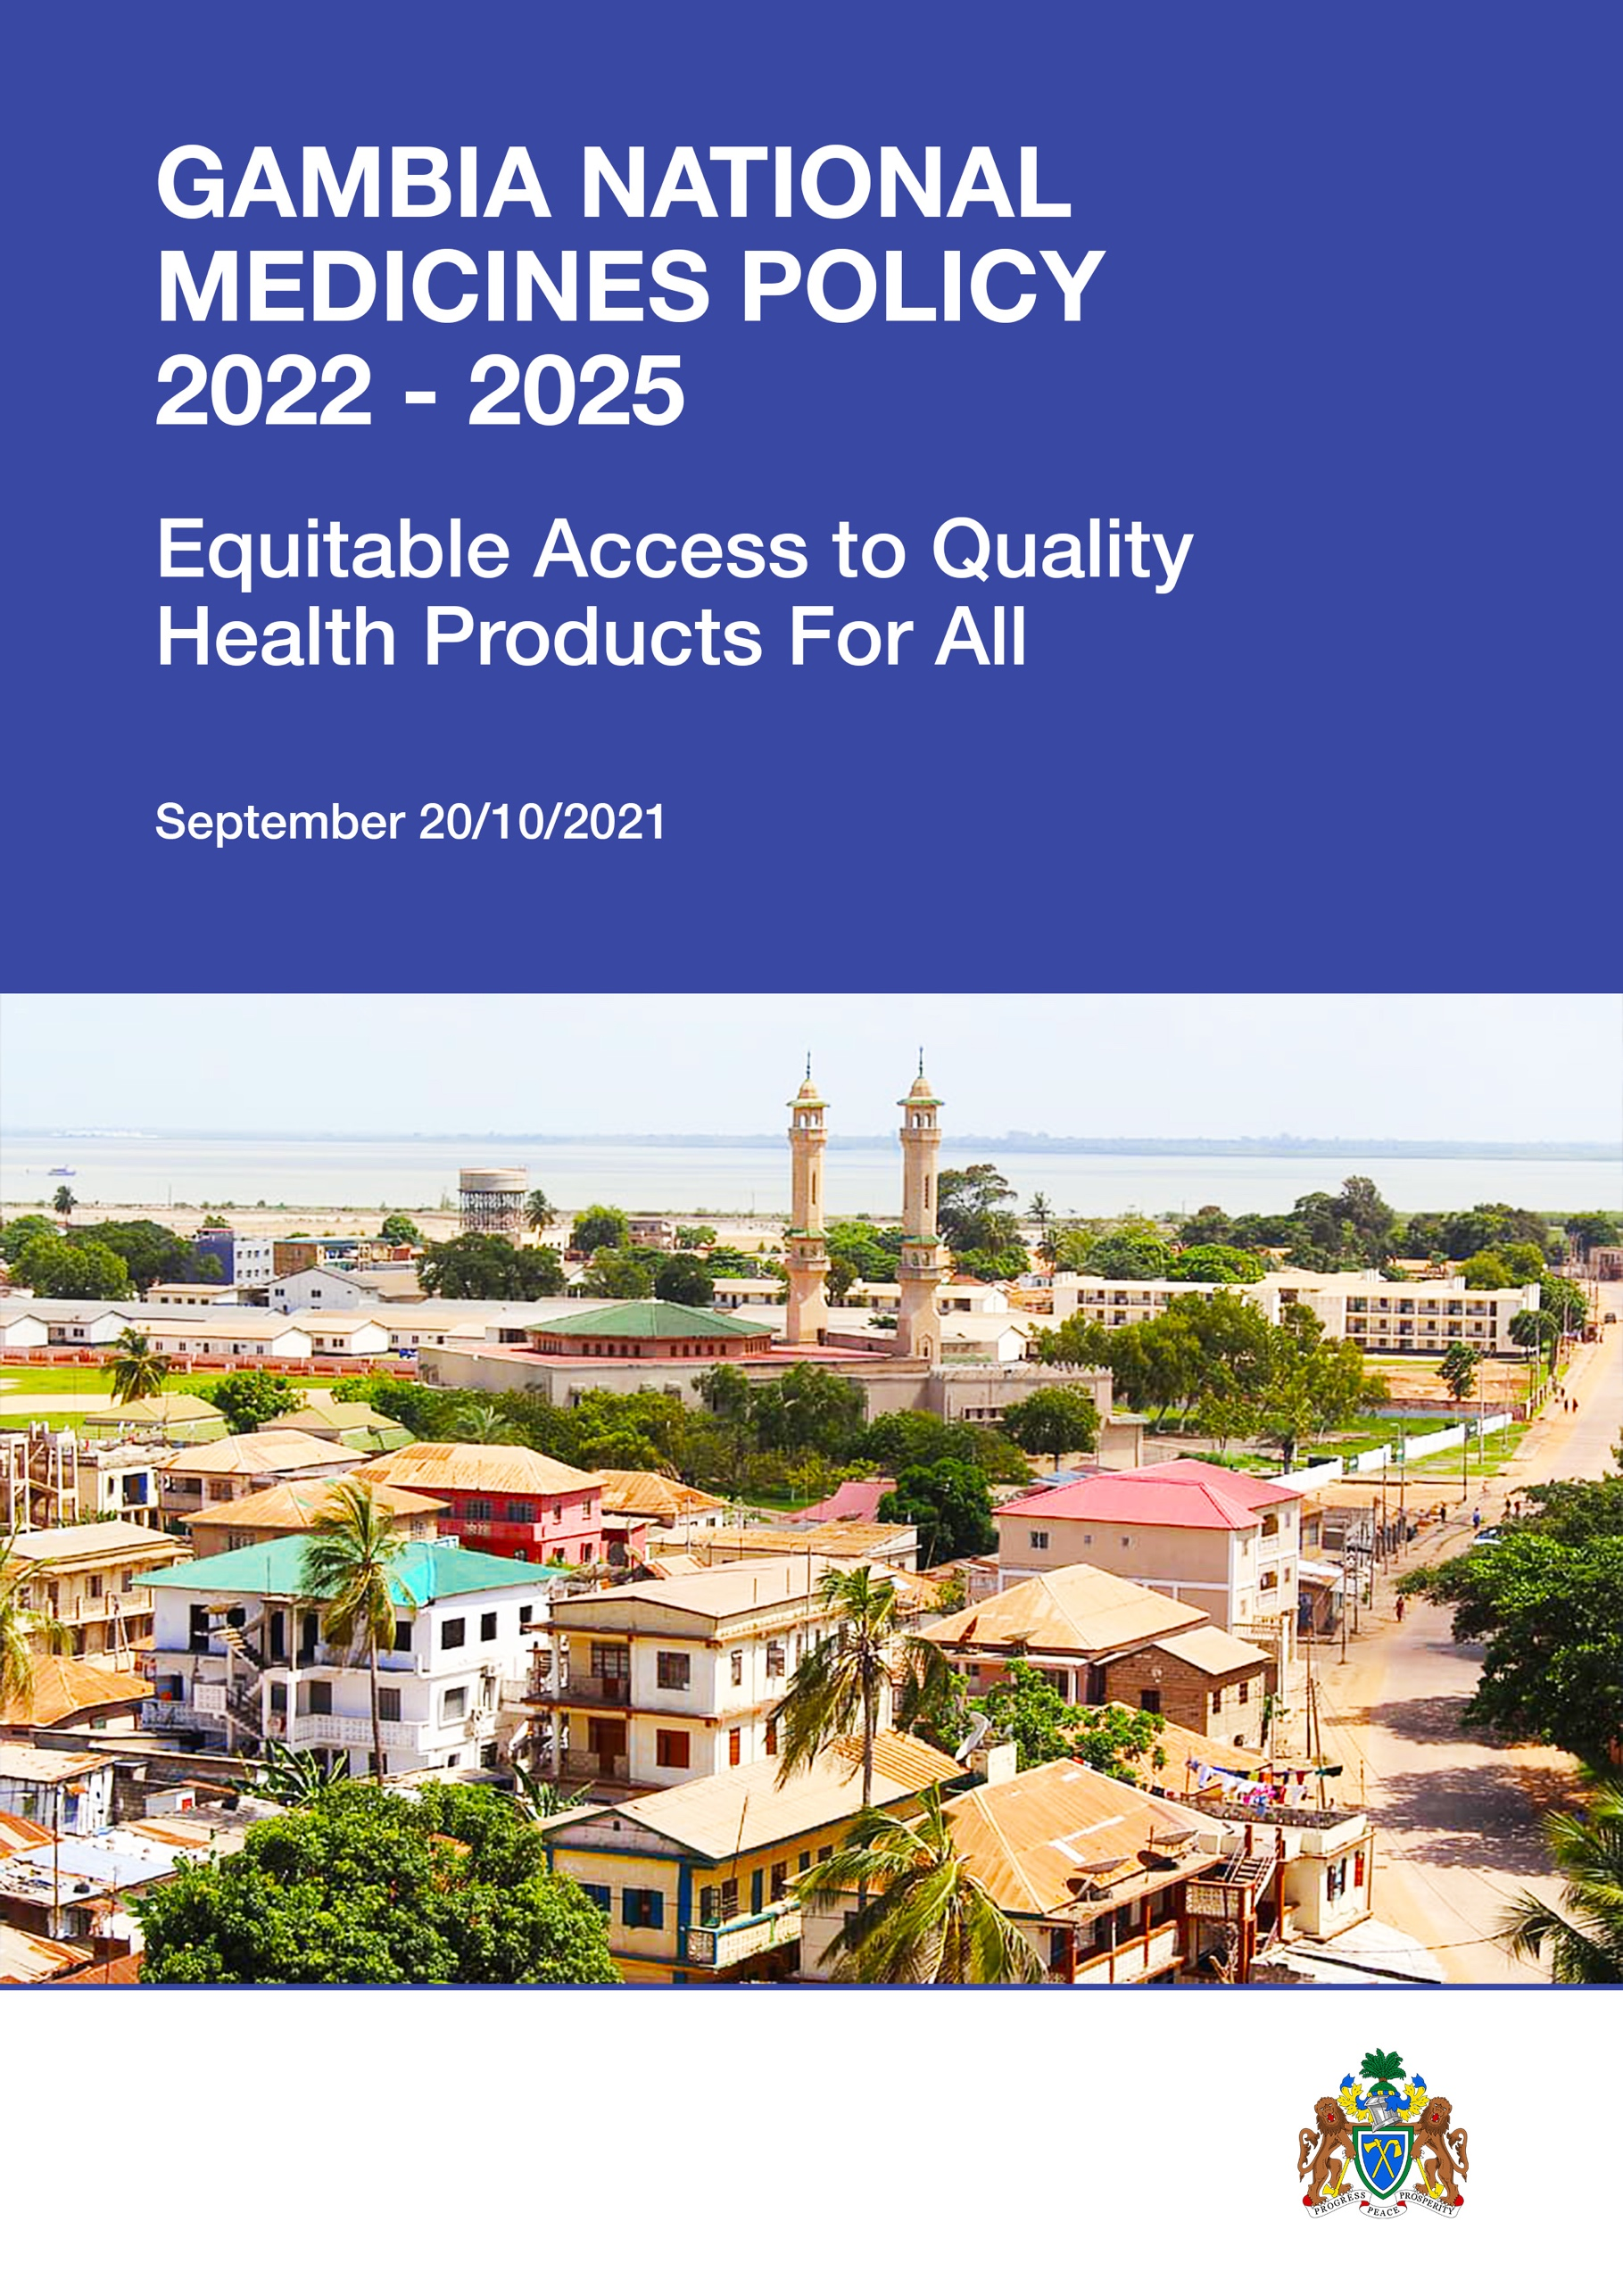


GAMBIA NATIONAL MEDICINES POLICY
2022 - 2025

Equitable Access ro Quality Health Products For All


01 June 2022

Contents
1 –PREFACE TO THE NATIONAL MEDICINES POLICY 2022-2025 10
2- Recent macroeconomic and financial developments 11
2.1. information 11
2.2. outlook and risks 11
2.3. Financing issues and options 11
3 - ORGANIZATION OF THE HEALTH SECTOR 12
4 - ORGANIZATION OF PUBLIC PHARMACEUTICAL SECTOR 12
4.1. FUNCTIONS of national Pharmaceutical services and Centre Medical stores 13
4.2. Functions of the Medicines control agency 13
4.3. Functions of the Pharmacy Council 14
5-Guiding principles 15
5.1. RIGHT to health 15
5.2 right of access to quality medicines and health technologies 15
5.3 evidence-based health care 15
5.4 Health System Reforms 15
5.6 Skilled staff retention and circulation 15
5.7. Partnerships 15
5.8. Equity 15
5.9 Gender Equity 16
5.10 Ethics and Standards 16
5.11 Client Satisfaction 16
5.12 Cultural Identity 16
5.13 good governance and ACCOUNTABILITY 16
5.14 climate change & green growth 16
5.15 ONE health approach 16
5.16 Patient bill of rights 16
6. VISION AND MISSION 18
6.1. Guiding Principles 18
6.2. Vision 18
6.3. Mission 18
7. GOAL AND OBJECTIVES 18
7.1. GOAL 18
7.2. Main objectives 18
8 – changing FOCUS 19
9- transformative action for core pharmaceutical system 20
9.1. legislation, bylaws, and institution building 20
9.6. Regulation: 21
9.2. Governance and Transparency 21
9.3. Pharmaceutical risk management 21
9.4. human resource development 21
9.5. Financial resources 22
9.7. Registration 23
9.8. Inspection 23
9.9. QUALITY control 24
9.10 quality assurance of pharmaceutical productS 24
9.11. Pharmacovigilance: 25
9.12. Drug pricing 25
9.13. Access to Essential Medicines, 26
9.14. Pharmaceutical Supply chain in public health sector 26
9.15. Medicines selection 27
9.16. Quantification 27
9.17. Procurement 28
9.18. Storage and inventory control 28
9.19. stock management and inventory control 29
9.20. Distribution, Service delivery and logistics 29
9.21. Rational use of medicines (RUM) 30
9.22. Hospital Pharmacy 30
9.23. Logistic management information system (LMIS) 31
9.24. information management system 31
9.25. Waste management 31
9.26. Local production 32
9.27. Traditional medicines 33
9.28. Research and development 33
9.29. Innovation 34
9.30. intellectual property 34
9.31. Intersectoral and technical cooperation 35
9.32. Pandemic Health crisis management 35
9.33.one health" approach 36
9.34. green and climate smart pharmaceutical practices 36
9.35. PUBLIC AND Private partnership (PPP) 36
9.36. Civil Society Organizations (Community Participation) 37
9.37. Decentralization 37
9.38. Monitoring and evaluation 37
10. IMPLEMENTATION OF THE NMP 38
10.1. COMMITMENT 38
10.2. MOBILIZATION OF STAKEHOLDERS: 38
10.3. MOBILIZATION OF RESOURCES: 38
10.4. COMMUNICATION AND ADVOCACY: 38
10.5. MONITORING AND EVALUATION OF THE NATIONAL MEDICINES POLICY 38

1 –PREFACE TO THE NATIONAL MEDICINES POLICY 2022-2025
National Medicine Policy (NMP) 2022 is the third edition produced by the Ministry of Health of The Gambia. The revision has been informed by the National Health Policy “Quality Health Care for All” (2021-2030), the current state of the Pharmaceutical Structure and the need to strengthen the sector as a key component of the health system to meet the ever-changing health needs of the population. These reflect concerns raised regarding access to medicines for managing existing and emerging diseases of public health importance such COVID-19 pandemic which significantly affected availability of health products worldwide with consequences on health systems.
The Gambian authorities, aware of these external challenges and in line with the National Health Policy "Quality Health Care for All" (2021-2030) have decided to adapt the national medicine policy. The various elements examined under the policy include but not limited to legislation, governance & transparency, human resources, financial resources, regulatory control, local manufacturing, traditional medicines, procurement and supply management functional areas, waste management, research & development, innovation, intellectual property, intersectoral and technical cooperation, pandemic health crises management, public-private partnership and decentralization, monitoring, and evaluation. In highlighting these areas, due cognizance has been given to available resources, potential of drugs in disease management and the socio-economic environment. The policy has also been formulated with an inherent flexibility to accommodate future developments and changes in the overall vision of attaining health for all including the introduction of the National Health Insurance Scheme.
Focusing on access to quality essential medicines for the populace, it is the aim of the Government of The Gambia to foster stronger partnerships for better pharmaceutical service delivery and subsequently better health for all Gambians. The pillars of the revised version are to integrate all the actors of the chain (Manufacturers, Public Authorities, Patients Associations and Health Professionals) on the strategic intervention areas of the NMP.
The NMP 2022 has been produced following consultation with various stakeholders of the health and pharmaceutical sectors to promote coherent endeavour required to achieve the objectives of the policy and bring about better health outcomes for the nation. In this light, each partner is expected to take responsibility and engage in a cooperative endeavour to contribute to the achievement of the objectives of the policy by tapping into their unique qualities and strengths. This document shall therefore remain the official policy to guide the pharmaceutical sector in The Gambia.
I wish to express my sincere appreciation to World Health Organization for both technical and financial supports, and all other technical experts, the Directorate of Pharmaceutical Services and to the pharmaceutical sector as a whole for their immense contribution and support towards the review of this policy.
…………………………………..
Dr. Ahmadou Lamin Samateh
Hon. Minister of Health

2- Recent macroeconomic and financial developments

2.1. information
Containment measures introduced to limit the COVID– 19 pandemic helped cause The Gambia’s GDP to contract by an estimated 2.4% in 2020, after growing 6.2% in 2019. On the supply side, the tourism and trade sectors were the most affected, while on the demand side, subdued domestic and external demand hurt the economy. The government responded with expansionary fiscal policy—health spending increased by 0.5% of GDP and food assistance increased by 0.7%. Monetary and financial policies were also eased—the policy rate was cut by 200 basis points to 10% to boost liquidity. Subdued aggregate demand pushed down inflation to an expected 6% in 2020 from 7.1% in 2019. The fiscal deficit widened to 3.7% of GDP in 2020 from 2.4% in 2019 as a result of increased spending amid a shortfall in revenue collections. The decline in remittances and tourism receipts widened the current account deficit to 8.6% of GDP from 5.3% in 2019. Foreign exchange reserves expected to drop by $10 million in 2020 to $258 million (3.7 months of import cover) while the foreign exchange rate stabilized at GMD 51 to the US dollar throughout the year. Public debt increased to 83.1% of GDP in 2020 from 81% in 2019—because of large fiscal deficits and government efforts to prop up state-owned enterprises (SOEs). The financial sector, although well capitalized and liquid, remains vulnerable to spillover effects of the pandemic on the ability of firms in the tourism, trade, and real estate sectors to service their loans. These three sectors account for 54% of total credit and one-third of non-performing loans. The pandemic has hurt social indicators. An estimated 20,000 jobs were lost in 2020, the unemployment rate was about 40%, and the poverty level was estimated at 48.6%.

2.2. outlook and risks
The outlook is positive, if the economy reopens, good rains aid agriculture, global demand improves, structural reforms are instituted on non-performing SOEs, monetary policy is accommodative, and negotiations to restructure public debt continue as a complement to fiscal consolidation efforts. Real GDP is projected to pick up gradually growing by 3.2% in 2021 and 5.1% in 2022. Inflation is projected to decline marginally to 5.9% in 2021 and 5.7% the following year. The fiscal deficit is projected to narrow to 3.2% of GDP in 2021 and 2.3% in 2022, while the current account deficit will widen to 10.4% of GDP in 2021 and 10.1% in 2022. Downside risks to the outlook emanate from possible spending pressures during the 2021 presidential election. Failure to secure external assistance and a delay in reopening economies are other potential downside risks.

2.3. Financing issues and options
The Gambia’s efforts to lift growth to its precrisis level could be constrained by adherence to stricter fiscal rules under an International Monetary Fund program and National Development Plan provisions for fiscal austerity. Therefore, The Gambia should explore external assistance to support its post-COVID–19 growth recovery. In this regard, The Gambia could capitalize on its past and ongoing debt restructuring and debt service deferment experiences. The G20 Debt Service Suspension Initiative, deferred payments, and debt restructuring of bilateral and multilateral credits have helped improve The Gambia’s debt distress rating to high risk from being in debt distress. The Gambia could also immediately introduce growth-friendly revenue enhancement measures—such as broadening the tax base, improving tax compliance, and streamlining exemptions. In the short to medium-term, the country could pursue deepening the financial sector to support private sector credit growth. Priority should be on obtaining new financing on highly concessional terms, seeking other financing options such as exchanging debt for development and multicreditor debt swaps, and exploring options for debt renegotiation to bring public debt onto a sustainable path.

3 - ORGANIZATION OF THE HEALTH SECTOR
National government health sector leadership resides in the MOH. This ministry comprises 9 directorates. At the executive level, the ministry is led by a minister and a permanent secretary. Directors of each of the directorate’s report to the permanent secretary. Functional responsibilities of the current MOH health directorates:
- Directorate of Health Services
- Directorate of Planning and Information
- Directorate of Pharmaceutical Services
- Directorate of Nursing Services
- Directorate of Public Health Services
- Directorate of National Public Health Laboratory Services
- Directorate of Human Resources for Health
- Directorate of Health Research
- Directorate of Health Promotion and Education
Regional health directorates (RHDs) are responsible for management and support of the seven regional health teams, which in turn are responsible for primary and secondary healthcare facilities and their staff in their respective regions.

4 - ORGANIZATION OF PUBLIC PHARMACEUTICAL SECTOR
The Legal framework for regulation of medicines and related products is the Medicines and related products Act 2014 which established the Medicines Control Agency. For pharmacy practice, the legal framework is the Pharmacy Council Act 2014 which also established the Council for the regulation of personnel and practice premises.
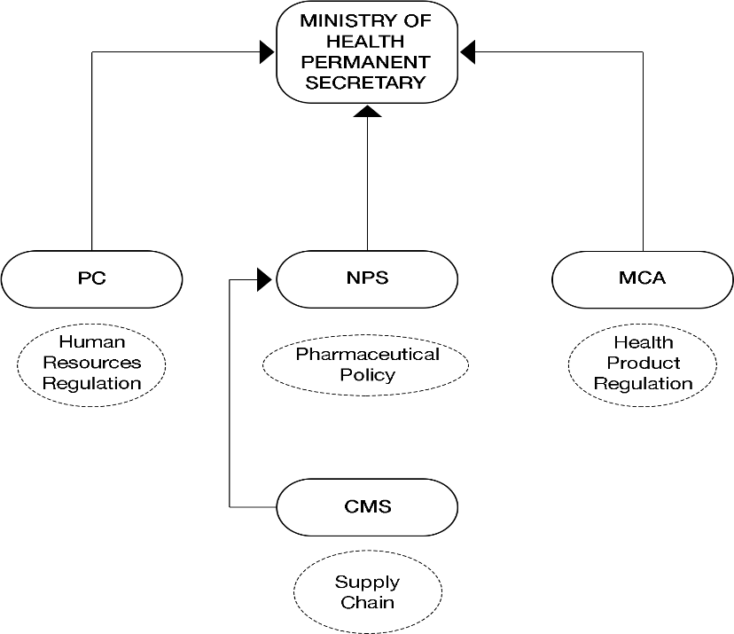

4.1. FUNCTIONS of national Pharmaceutical services and Centre Medical stores
- Coordinate Policy formulation and implementation.
- Coordinate monitoring and evaluation of NMP Implementation.
- Coordinate dissemination of monitoring and evaluation reports.
- Coordinate pharmaceutical human resources development.
- Coordinate regular update of the National Essential Medicines List treatment guidelines and other gridlines.
- Procurement and Supply Management of Medicines and other medical supplies for the public sector pharmaceutical services delivery.
- Ensure quality pharmaceutical care to the populace.

4.2. Functions of the Medicines control agency
- Regulate all matters relating to efficacy, quality and safety of medicines and related products.
- Regulate in accordance with this Act, the importation, manufacture, labelling, marking or identification, storage, promotion, sale and distribution of medicines and or any related product, materials or substances used in the manufacture of products regulated under this act.
- Ensure that evidence of existing and new adverse events, interactions and information about pharmacovigilance of products being monitored globally, are analyzed and acted upon.
- Ensure that, clinical trials on medicines and related products, and herbal medicines are being conducted in accordance with prescribed standards.
- Foster co-operation between the Agency and other institutions or organizations and other stakeholders.
- Approve and register medicines and related products regulated under this Act, manufactured within or imported.
- Examine, grant, issue, suspend, cancel and revoke certificates and licenses or permits issued.
- Appoint inspectors and order inspection of any premises.
- Promote the rational use of medicines and herbal medicines.
- Establish and maintain the Gambia National Formulary and Pharmacopoeia.
- Provide the public with unbiased information on products regulated under this Act.
- Control of advertisements of medicines and related products.
- Prescribe standards of quality in respect of products regulated under this Act, Manufactured or intended to be manufactured or imported into or exported from the Gambia.
- Maintain registers pertaining to regulation of medicines and related products prescribed.
- Be responsible for its human resource management and development.
- Promote, monitor and ensure successful implementation of the provisions of this Act relating to medicines and related products.
- Attend to and where possible, take legal measures on complaints made by consumers against manufacturers of products regulated.
- To ensure that all forms of medicines handling (importation, exportation, warehousing, distribution, manufacturing) are appropriately regulated.
- Provide the required human, technical, financial, and logistical capacity for the effective application of the legislation.
- To ensure that the pharmaceutical professional practices are effectively monitored and controlled.

4.3. Functions of the Pharmacy Council
- Determine the standard of knowledge and skill to be attained by persons seeking to become members of the pharmacy profession and pharmacy support personnel and reviewing those standards from time to time.
- Evaluate and monitor the standards of courses and training for registered persons.
- Issue practicing certificates to persons and to cancel or suspend such certificates in terms of this Act.
- Prescribe and enforce practice standards, conduct, and discipline among registered persons; promote the highest standards of pharmacy practice.
- Maintain registers prescribed under this Act relating to pharmacy practice.
- Promote, monitor and ensure successful implementation of the provisions of this Act relating to pharmacy practice.
- Attend to and where possible, take disciplinary measures on complaints made by consumers.
- Carry out such other functions as may be conferred upon the Council by any written law or as are incidental to the performance of its functions under this Act; establish standards and provide guidelines for continuing professional development •and training of registered Pharmacists and pharmacy support personnel.
- Register and maintain registers for pharmacists and pharmacy support personnel.
- Advise the Minister on pharmacy practice and measures to protect the health and safety of consumers and the general public.
- Encourage cooperation between the Council and other sister councils.
- Advise the Minister on developing effective regulations for the implementation of the Act; and do such acts or take such measures as are, in the opinion of the Council, necessary or expedient for the prevention of health hazards to consumers which may result from the practice of pharmacy as regulated under this Act.

5-Guiding principles

5.1. RIGHT to health
The right to health includes timely to acceptable, quality, and affordable health care.

5.2 right of access to quality medicines and health technologies
Access to essential medicines is a fundamental element of the right to health.

5.3 evidence-based health care
Health planning, programming and service delivery shall be informed by evidence-based research.

5.4 Health System Reforms
Devolution of political and managerial responsibilities, resources and authority in line with the Government decentralization program; capacity building for the decentralized structures (institutions).

5.6 Skilled staff retention and circulation
Attractive service conditions (package); job satisfaction to encourage a net inflow of skills.

5.7. Partnerships
Community empowerment; active involvement of the private sector, NGOs, local government authorities and civil society; effective donor co-ordination.

5.8. Equity
Provision of health care shall be based on comparative need. Accessibility and affordability of quality services at point of demand for the marginalized and underserved, irrespective of political national, ethnic or religious affiliations.

5.9 Gender Equity
The planning and implementation of all health programs should address gender sensitive and responsive issues including equal involvement of men and women in decision-making; eliminating obstacles (barriers) to services utilization; prevention of gender-based violence.

5.10 Ethics and Standards
Respect for human dignity, rights, and confidentiality; good management practices and quality assurance of service delivery.

5.11 Client Satisfaction
Accessibility to twenty-four-hour quality essential services care and blood transfusion services; reduced waiting time; empathy in staff attitudes; affordability and adequate staffing in health facilities.

5.12 Cultural Identity
The recognition of the importance of local values and traditions, and use of traditional structures such as Kabilos, kaffos, traditional healers and religious leaders.

5.13 good governance and ACCOUNTABILITY
Good governance is an essential for improving the effectiveness of quality health services and meeting the needs of the vulnerable people.

5.14 climate change & green growth
Climate change is a long-term change in the average weather patterns that have come to define Earth's local, regional, and global climates. These changes have a broad range of observed effects that are synonymous with the term. ...

5.15 ONE health approach
One Health' is an approach to designing and implementing programs, policies, legislation, and research in which multiple sectors communicate and work together to achieve better public health outcomes. The ‘One Health’ approach is critical to addressing health threats in the animal, human and environment interface.

5.16 Patient bill of rights
The Patient's Bill of Rights helps patients feel more confident in the health care system. It assures that the health care system is fair, and it works to meet patients' needs; gives patients a way to address any problems they may have; and encourages patients to take an active role in staying or getting healthy.
5.16.1 Information disclosure
Patients have the right to accurate and easily understood information about his/her healthcare plan, health care professionals, and health care facilities. This must be done using a language understood by the patient so that he/she can make informed health care decisions.
5.16.2 Choice of providers and plans
Where possible every patient shall have the right to choose health care providers who can give him/her high-quality health care when needed.
5.16.3 Access to emergency services
In emergency health situations including severe pain, an injury, or sudden illness that makes a person believe that his/her health is in serious danger, he/she shall have the right to be screened and stabilized using emergency services. He/she should be able to use these services whenever and wherever needed without needing to wait for authorization and any financial payment.
5.16.4 Participation in treatment decisions
Every patient shall have the right to know his/her treatment options and take part in decisions about his/her care. Parents, guardians, family members, or others that they identify can represent them if he/she cannot make his/her own decisions.
5.16.5 Respect and non-discrimination
Every patient must have a right to considerate, respectful and non-discriminatory care from his/her health care provider (s).
5.16.6 Confidentiality of health information
All patients must have the right to talk privately with health care providers and to have his/her health care information protected. He/she shall have the right to read and copy his/her own medical record. He/she shall have the right to ask that his/her health care provider change his/her record if it is not correct, relevant, or complete.
5.16.7 Complaints and appeals
Every patient shall have the right to a fair, fast, and objective review of any complaint he/she may have against any health plan, health care provider/personnel or health institution. This includes complaints about waiting times, operating hours, the actions of health care personnel, and the adequacy of health care facilities.

6. VISION AND MISSION

6.1. Guiding Principles
Recognizing the basic human right of access to acceptable healthcare, the policy shall be guided by the principles of assuring equity in accessing safe and efficacious essential medicines, focusing particularly on the more vulnerable members of society.

6.2. Vision
Ensure the quality and availability (including last miles) of all health product authorized in The Gambia throughout the pharmaceutical chain (registration, local manufacturing, importation, reception, storage, distribution, rational use, pharmacovigilance) by decentralizing services.

6.3. Mission
To overcome stock-outs, overstocking and the risks of infiltration of falsified health product into the supply chain; In general, to promote a holistic vision of access to quality medicines, taking into account gender equality and equitable access to health care for the different categories of the population, especially the most vulnerable, in the target geographical areas.

7. GOAL AND OBJECTIVES

7.1. GOAL
The overall goal of the National Medicines Policy 2021 is to contribute in its part to the attainment of the highest possible health standards for the Gambian populace, through the *continuous* availability, accessibility, affordability and appropriate use of essential medicines of appropriate quality, safety and efficacy.

7.2. Main objectives
- To provide a comprehensive legislative and regulatory framework that allows for the protection and promotion of health for the Gambian populace, by ensuring compliance of pharmaceutical products, personnel, premises and practices with the relevant legislation.
- To institute a sustainable financing mechanism that ensures availability and equitable access to adequate quantities of the required essential medicines.
- To ensure that all medicines selected are relevant to the priority needs of the populace and are procured in a manner that assures their quality, safety, efficacy and cost effectiveness.
- To ensure that medicines are used by prescribers, dispensers and consumers in a manner that promotes maximum therapeutic benefit through continuous education and health promotion.
- To strengthen the human resource capacity in the pharmaceutical cadre (both public and private).
- To enhance research capacity at all levels.
- To establish a robust Pharmaceuticals Management System that ensures availability and accessibility of information on pharmaceuticals and promotes the utilization of such information for higher decision making.
- To create an enabling environment to encourage local production of pharmaceuticals.
- To maximize the benefits of Traditional and Complementary Medicines (TCM) where possible and desirable and protect the public against their possible negative effects.
- To promote partnership through the active participation of all stakeholders, particularly the private sector for the effective implementation of the policy.
- To harness the synergies at regional (including community), national and international levels to maximize the implementation of the policy.
- To establish a mechanism of coordinating, monitoring and evaluating the implementation of the NMP, in close collaboration with all relevant stakeholders.

8 – changing FOCUS
From core functions to outcome
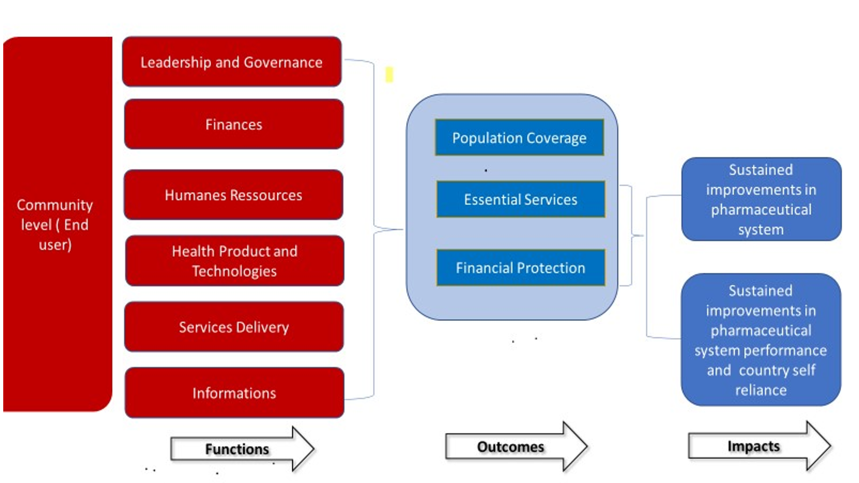
Outcome of NMP
- Population coverage: Equity focused access to services for poor and marginalized.
- Essential services: capacity to deliver an essential package of Hight quality services to those who needed it.
- Financial Protection: Cost of accessing services does not impoverish or curb necessary care.

9- transformative action for core pharmaceutical system

9.1. legislation, bylaws, and institution building
Preamble
The Medicines Act of 1984 established the Medicines Board under the ministry of Health to regulate medicines and related products, pharmaceutical practice, and personnel in the pharmaceutical sector. The ministry of Health in 2014 achieved a major reform with the separation of regulatory functions. The Medicines Act 1984 was repealed in 2014 with the enactment of the Medicines and Related Products Act, 2014 which established Medicines Control Agency and the Pharmacy Council 2014 which established the Pharmacy Council.
The pharmaceutical sector regulatory bodies are still fairly young, with limited financial, human resources and expertise. This has meant that the inspectorate arms and the Quality Assurance Departments are still underdeveloped, and thus potential activities under-utilized.
The regulation of Medical and Dental practices is enshrined in the Medical and Dental practitioners Act 1988 and for nursing practice, the Nurses, and Midwives Act 1990 for nursing. The Medical Services Act 1988 regulates medical services. However, most of these Acts are old and with their limited execution. There is no AMR policy and weak governance structures at the regional levels coupled with weak coordination with other agencies/institutions. Non-separation of the functions of NPS and CMS are also major implementation challenges.
Current systems in place for control of imports are not resilient enough and most players in the industry expect this to be strengthened in order to improve the quality of medicines and related products in the country.
Currently there are overlaps in some functions stipulated in the Medicines and Related Products Act and the Pharmacy Council Act with respect to the Inspection and Licensing of Pharmaceutical Premises. However, this issue was recognized and resolved through a Memorandum of Understanding (MOU) between the Medicines.
Illegal sale of medicines in the open market, Inadequate Human Resources for the MCA and Inadequate public education on the safe use of medicines and related products are others challenge for regulation.

Policy Statement: Positioning the pharmaceutical sector to a successful system that can meet the current and future needs of the Gambian population.
Policy Strategy:
To review and revise current legislations and regulations to align with best pharmaceutical practices
Provide the necessary financial and human resources for the implementation of the national pharmaceutical policy.

9.6. Regulation:
Preamble

Policy Statement: Improve legislative and regulatory framework to ensure that medicines are of acceptable safety and quality according to approved standards and specifications.
Policy strategy:
Digitalize regulatory functions to further strengthen its performance.

9.2. Governance and Transparency
Preamble
The National Medicines Policy 2007 is a national guide to pharmaceutical governance and transparency. However, in order to address the current situation, the policy needs to be updated.
Policy Statement: A pharmaceutical governance and transparency system in accordance with national and international best practices.
Policy Strategy:
Develop and implement a national Guideline of Good Governance for pharmaceutical sector implementing agencies

9.3. Pharmaceutical risk management
Preamble
The country does not have a national guide for pharmaceutical risk management.
Policy Statement: A proactive pharmaceutical system with risk management strategies
Policy Strategy:
Develop and implement a national guideline for risk management in the pharmaceutical sector.

9.4. human resource development
Preamble
The Pharmaceutical sector comprises Pharmacists and Pharmacy support staff. The training of pharmacists is done abroad whilst pharmacy technicians and dispensing assistants are conducted locally at the University of The Gambia, and American International University, West Africa
The overall ratio of skilled health workers per 1,000 population is 1.33, fewer than the WHO recommendation of 2.25 health workers per 1,000 population.
The ratio of pharmacists and pharmacy support staff stands at 0.029944 per 1000 population (HRH Assessment Report, July 2018). The limitation in numbers of pharmaceutical staff means that, the management of pharmaceuticals is carried out by nursing staff in some health facilities.
Policy Statement: Provide competent, motivated, committed pharmaceutical human resources, equitably distributed throughout the country.
Policy strategy:
Develop and implement a five-year human resource development plan for the pharmaceutical sector.
Develop a digital platform for continuing training on pharmaceutical practices.

9.5. Financial resources
Preamble
Government health expenditure as percentage of the Total Health Expenditure (THE) was 38.60% in 2016 and decreased to 30.6% in 2017. However, the 2016 and 2017 National Health Accounts (NHA) results indicated that the health sector is mainly funded by external sources, 31.6% and 44.8% respectively. Similarly, government contribution to the procurement of medicines and related products is ranging from US$ 0.40 to US $ 1.04 per capita over the past five years which is less than the recommended WHO threshold of US$2.00 per capita. (Public Expenditure Report, 2018).
Although the Drug Revolving Fund (DRF) as a financing strategy and later the Bamako Initiative (BI) were both introduced, access to and utilization of these funds remains a challenge. The ministry has adopted Result-Based Financing (RBF) as a mechanism to be implemented country wide, following the implementation of the RBF by the World Bank through NaNA and MoH. In addition, the ministry has embarked on instituting a National Health Insurance Scheme as an additional financing mechanism for the health sector towards the achievement of Universal Health Coverage.
This will enhance equity in access to health care and availability of medicines and related products for the population particularly the poor and the vulnerable.
Policy Statement:
Securing adequate financing and payment mechanism for health products.
Policy strategy:
Government shall set up financing mechanisms for sustainable financing of health products. (cost recovery, domestic resource mobilization, National Health Insurance Scheme)
Promote optimal prioritization/use of investments using risk-based approaches

9.7. Registration
Preamble
There are products circulating in the country without Marketing Authorization. Additionally, the country has very limited technical capacity to implement the Common Technical Documents (CTD) Guidelines and the assessment of the marketing authorization request.
Limited number of registered Medicines and Related Products and weakness of procedures and means dedicated to the evaluation of pharmaceutical products (Procedures and means dedicated to the evaluation of Marketing authorization applications are insufficient).
Clinical trials conducted in The Gambia need more thorough follow-up.
Policy Statement: The Gambia pharmaceutical sector has a national technical capability that is transparent and in compliance with guidelines procedures to ensure that all products circulating in Gambia have a Marketing authorization.
Policy strategy:
To ensure an effective and reliable medicines registration system

9.8. Inspection
Preamble
The Practice of Pharmacy in The Gambia is regulated by The Pharmacy Council. Amongst other functions, the PCG is responsible for inspecting licensed premises to assess level of compliance relevant provisions of the Pharmacy Act. However, PCG has inadequate human resource and technical competence, as well as financial and logistics support to conduct regular inspection.
Policy Statement: protect the health and safety of the general public through safeguarding, maintaining, and enforcing the highest standards in the practice of Pharmacy.
Policy strategy:
Develop standards and guidelines for inspection of manufacturing plants, warehouses, public and private pharmaceutical premises as well as pharmaceutical practice and personnel.
Establish effective mechanisms for inspection of manufacturing plants, warehouses, public and private pharmaceutical premises as well as pharmaceutical practice and personnel.
strengthen and maintain effective inspectorate services PCG.

9.9. QUALITY control
Preamble
MCA is the National Regulatory Body responsible to ensure the quality, safety and/or efficacy of medicines, and related products. Amongst other functions, MCA is mandated to analyse the quality of medicines and related products to ensure that products meet quality standards. However, the QC services is outsourced due lack of a national medicines quality control testing laboratory and inadequate post marketing surveillance system.
Policy Statement: capacitate MCA to undertake QA and QC responsibilities/functions
Policy strategy:
Undertake QA and QC to safeguard quality, safety and/or efficacy of imported health products.
Set up a functioning Quality Control Laboratory in cooperation with African Vision and other partners.

9.10 quality assurance of pharmaceutical productS
Preamble
MCA is the National Regulatory Body responsible to ensure the quality, safety and/or efficacy of medicines, and related products. Amongst other functions, MCA is mandated to analyse the quality of medicines and related products to ensure that products meet quality standards. Medicines Control Agency has been certified for Quality Management System with ISO 9001:2015 in 2019 and has embarked on web-based registration of Medicines and Related Products. MAC developed and introduced a Pharmaceutical Quality Assurance Plan including Procurement and Regulatory activities e.g., Inspection and Enforcement. In addition, MCA provides oversight function for Clinical Trials with approval from The Gambia Government- MRC Joint Ethics Committee.
However, reinforcing current QA arrangements for imported health program remain a challenge as there are still substantial number of unregistered Medicines in the Gambian market.
Policy Statement: All Medicines made available to the patients must be safe, efficacious, and meet the approved specifications and standards
Policy strategy:
Improve governance for health product quality assurance system (Evidence -based health product quality assurance legislation, regulation, and policies).
Improve country regulatory system (Market authorization/ registration, inspection and licensing functions).

9.11. Pharmacovigilance:
Preamble
The MCA is mandated to control the manufacture, importation, exportation, distribution, use and advertisements of medicines and related products to ensuring their quality, safety, and efficacy. Amongst other functions, MCA is responsible for monitoring, and analysing evidence of existing and new adverse events, interactions, and information about pharmacovigilance of products and act upon.
However, monitoring and reporting on the safety of medicines and related products still a challenge, particularly most healthcare practitioners. Other challenges include:
- Implementation of pharmacovigilance requires training and retraining of health practitioners.
- There is no Poisons Centre to support the optimal functioning of the pharmacovigilance system.
- Limited technical and financial resources
Policy statement: protect patients of the risks associated with the use of health products and having a clear picture of adverse events occurring throughout the country.
Policy strategy:
Migrate to or adopt an e-pharmacovigilance system
Improve a pharmacovigilance risk management system
Improve the capacity to undertake pharmacovigilance responsibilities

9.12. Drug pricing
Preamble:
The current budgetary allocation is inadequate to meet actual health needs of the populace. Recently, the institution of nominal registration fees at RVH, BH and the Regional Clinics is orienting the population to the concept of payment for services.
Moreover, public drug prices are comparable private sector pricing scale, an industry that is quite visible in the greater Banjul area and drug supplies into private sector is somewhat more reliable than the government's acquisitions.
Despite the institution of cost recovery program, drug pricing in public pharmaceutical sector is not well defined. There is no mechanism to monitor transparency in drug pricing. Factors that contribute to the inflated prices of medicines, such as taxes and tariffs need to be removed.
Policy Statement: A substantiable health products pricing system, with regulation and reference pricing mechanisms that ensures that prices of essential medicines are maintained at levels affordable to the population.
Policy strategy:
Improve the health products pricing mechanism and promote medicines affordability in Gambia
Encourage government to exempt VAT on raw materials to promote local production of pharmaceuticals

9.13. Access to Essential Medicines,
Preamble:
Government budgetary allocation for health products has not increased significantly lately. There has been a major increase in demand due to population increase and coupled with the rapid expansion of health facilities. These factors contribute to the periodic shortages of medicines and other medical supplies. The bureaucratic process involves in the procurement of pharmaceuticals and other medical supply requires improvement.
Despite the implementation of programs for the most vulnerable, access to products remains problematic in certain areas and for a certain category of population. Geographic and financial access remains a challenge.
Policy statement: Make access to products for all by the populace a priority, including the poorest and most vulnerable.
Policy strategy:
Leverage on Health Insurance Scheme to affordability of health products by the community
Innovate and sustainable distribution model for last mile delivery of health commodities to health facilities.

9.14. Pharmaceutical Supply chain in public health sector
Preamble:
Despite these investments in the strengthening the health supply chain system in The Gambia, the system is yet to achieve essential security for some of the required health commodities, as there are still challenges in meeting the required human resource needs; inadequate storage and distribution capacity as well as challenges in getting quality logistics data in time to inform decisions.
Policy statement: Provide an uninterrupted supply of quality health product to end-users.
Policy strategy:
Provide CMS and decentralized structures the financial, human, technical, organizational, resources to have a Capability and capacity according to international guidelines and based on the principles of value for money.
Provide Technical assistance to MCA for the implementation of its strategic organization according to the WHO MQAS Guide.

9.15. Medicines selection
Preamble:
The Gambia Essential Medicines List (GEML) and Standard Treatment Guidelines (STG) were first developed in 1984 and were last updated in 2017.
There is no Medicines and Therapeutic Committee.
The GEML and Standard Treatment Guidelines (STG) were first developed in 1984 and were last updated in 2017. The GEML comprise of an estimated total of 391 essential medicines. Between 2017 and 2018, the MoH procured only 36% of the products on the GEML. Of that, 47% and 38% of procured items were those categorized for use at the primary and secondary care levels of the health system, respectively. Importantly, it procured just 12% of GEML items categorized for use at the tertiary care level (HSSA report, 2020). The GEML and STG have not been updated regularly due to the non-existence of a Medicines and Therapeutic Committee.
Policy statement: Use the principles of evidence-based essential drug lists, with a focus on prevalence of prevalent diseases and health technology assessment mechanisms.
Policy strategy:
Apply economic evaluation strategy grounded in research and the scientific method to support evidence-based selection and pricing decisions.
Use GEML and STGs as a basis for procurement, prescribing and dispensing in the public health sector and promote its use in the private sector.
Use health technology assessment to support evidence-based selection, pricing and purchasing decisions.

9.16. Quantification
Preamble:
Since 2017 the MoH established a National Quantification Committee (NQC) responsible for the quantification of essential medicines and other medical consumables required for the public sector. The Quantification process involves all stakeholders including those at periphery user end. However, the lack of reliable data, SOPs and guidelines on quantification and the required capacity hinder the quantification process. Given the data challenges faced currently in the quantification process, a mix method including utilization of consumption, epidemiological and demographic data are applied.
Policy statement: Coordinate all the needs of all the actors and that the data are reliable
Policy strategy
Improve data processing capacity and quantification at all levels
Improve interoperability between medicine management information system and Health Management Information System to allow timely availability of reliable morbidity and consumption data.

9.17. Procurement
Preamble:
There is always a designated budget line for the procurement of essential medicines and consumables for the public health sector. However, the budget allocated is always insufficient to meet the projected needs of public thus, creating shortage. The GEML comprise of an estimated total of 391 essential medicines. Between 2017 and 2018, the MoH procured only 36% of the products on the GEML. Of that, 47% and 38% of procured items were those categorized for use at the primary and secondary care levels of the health system, respectively. Importantly, it procured just 12% of GEML items categorized for use at the tertiary care level (HSSA report, 2020).
There is no standard process to evaluate the executed procurement tasks. Furthermore, data tracking of procurement activities, contracts, and suppliers is not always available. Thus, there is no clear performance system in place to monitor contracts or orders and working with suppliers.
Policy statement: Improve the acquisition process for essential health products including during pandemics case (avoid stock outs and product losses due to expiration).
Policy strategy
Coordinate and collaborate on legal and regulatory requirements for ratification LTA with suppliers
Coordinate and collaborate on possible joint procurement within ECOWAS member country or other individual countries

9.18. Storage and inventory control
Preamble:
Currently, there exists a CMS and earlier investments in the public sector led to the construction of Regional Medical Stores which further enhanced the decentralization of the supply chain. The current arrangements are that the Central Medical Stores under the management of the National Pharmaceutical Services is responsible for the storage of essential medicines and health consumables. Despite the existence of the Regional and Central Medical Stores, storage capacity remains a challenge. This coupled with inefficient security and the non-existences of a risk management plan, limited number of trained personnel (at the CMS and RMSs) continue to affect the performance of the supply chain system.
The main challenges are the inadequate storage capacity, inefficient security and the non-existences of a risk management plan, limited number of trained personnel (at the CMS and RMSs). These continue to affect the performance of the supply chain system. At the central level, the CMS applies the mSupply licensed software while at the RMSs and some hospitals uses the CHANEL software. The CHANEL is not interoperable causing lack of visibility between CMS, RMSs and the hospitals.
Policy statement: Provide suitable, compliant, and adequate storage facilities (to avoid degradation of products due to non-compliant conditions).
Policy strategy:
Improve warehousing capacity for the CMS to adequately accommodate growing needs for health products
Upgrade health facilities storage capacity throughout the country to meet minimum standard storage conditions

9.19. stock management and inventory control
Preamble:
The management of the stocks is done by manual process generating much waste of time and defect of traceability.
Policy statement: improve the performance and productivity of health product logistic in CMS, regional warehouse, and pharmacy hospital.
Policy strategy: Implement a national roadmap for the digitalization of stock management in CMS, Regional warehouse, and pharmacy hospital.

9.20. Distribution, Service delivery and logistics
Preamble:
The CMS have four trucks to facilitate the distribution of essential medicines and health consumables to the seven RMS and public hospitals. However, there is a lack of utility vehicles at the CMS to support pick up of commodities from the ports.
RMS fleet capacity to conduct the last mile distribution is impacted by the lack of dedicated transportation between the RMS and health facilities affecting availability of essential medicine and consumables at the user end.
Policy statement:
A reliable and sustainable medicines distribution system to achieve last mile delivery
Policy: Strategy:
Improve national system for distribution with effective monitoring and maintenance mechanisms

9.21. Rational use of medicines (RUM)
Preamble:

The existence of the National Standard Treatment Guideline and the Essential Medicines List in 2017 have contributed to the gains of RUM.
However, there is weak regulation around the prescribing and use of medicines, especially antimicrobial agents. There exists no Antimicrobial Resistance Policy (AMR) and no programme on Stewardship.
There is inadequate qualified health personnel, no National Formulary, weak Pharmacovigilance structures,) and weak Laboratory Services, which have all negatively impacted on rational use of medicines.
In addition, there is no medicines information centers.
Therefore, the need for the Review of Policies and Strategies to maximize the gains towards Rational Use of Medicines in The Gambia.
Policy statement: improve rational use of medicines and vaccines to maximize their therapeutic benefit.
Policy strategy:
Regulate prescribing and dispensing practices and strengthen the regulation on promotional activities on medicines and vaccines.
Promote information, education, and communication on the use of medicines for the population.

9.22. Hospital Pharmacy
Preamble:
The are many challenges in pharmacy hospital as out of stock, the limited capacity warehouse (and conformity), and the software management system for traceability of dispensing.
Policy statement: provide for good health product management provisions in hospital settings
Policy strategy:
Improve quality and access to essential medicines in district and general hospital

9.23. Logistic management information system (LMIS)
Preamble:
The current LMIS requires facilities to collect and report logistics data every month. All health facilities collect and report logistic data to the Regional Medical Stores where data is aggregated for onward submission to the central level. The CMS aggregates information from all RMS to generate national stock report that is later shared with key stakeholders. There are SOPs and Job Aid to guide supply chain workforce on procedures for collecting, reporting and sharing logistics data.
The logistics management information system uses a mix of both paper- based and electronic inventory control tools. At the central level, the CMS applies the mSupply licensed software while at the RMSs and some hospitals use the CHANEL software. The CHANEL is a stand-alone software causing lack of visibility between CMS, RMSs and the hospitals.
Policy statements: Timely and high-quality logistics information is available for decision making and resource allocation.
Policy strategy:
Assess and develop the IT requirements and specifications for an eLMIS system

9.24. information management system
Preamble:
The current National Health Information System in The Gambia uses both paper-based in the form of registers and monthly returns at the facility level and electronic systems at the RHDs and central level. The electronic system includes District Health Information System (DHIS2), Human Resources Information System (HRIS), the Logistics Management Information System (LMIS), and the Integrated Diseases Surveillance and Response (IDSR).
There is an ICT Unit within the MOH under the DPI however, there is absence of an ICT Policy and Guidelines for the sector to guide on data management and protection. Generally, there need for guidelines, skilled staff, and improved ICT infrastructure to facilitate a transition from paper-based to electronic base health information System.
Policy statement: improve availability of reliable and adequately protected data.
Policy strategy:
Regulate medicines related promotions and advertisement

9.25. Waste management
Preamble:
Health-care waste (HCW) is waste generated during the cause of delivering health care services. Health-care wastes include sharps, infectious non-sharps materials, blood, body parts and fluids, chemicals, pharmaceuticals, radioactive materials.
One of the Medicine policies is to ensure that all medical waste are disposed of promptly, efficiently, and safely. The policy mandates the MCA to ensure suitable methods of disposal of unwanted or pharmaceutical waste, medical and surgical items are in operation across the country. However, despite this policy being in place health facilities seem to have a serious problem of appropriately disposing of medical waste such as expired drugs.
The WB financed Project is supporting the MOH to establish healthcare waste management across the country that is environmentally friendly:
- Two state-of-the-art health care waste treatment machines, which are automated and employ microwave technology have been procured
- Construction of two clinical waste treatment centres, one located at Farato and the other at the Edward Francis Small Teaching Hospital for the Ecosteryl machines.
- Seven containerized environmentally friendly and energy efficient dual chamber incinerators; one for each region can be moved from one place to another for waste treatment.
- Four refrigerated waste collection trucks and 120 wheelie bins that will collect and transport healthcare waste from various health facilities to the waste treatment centres.
- Additionally, orders have been placed for 40 dual chamber incinerators to be installed at health centres and hospitals across the country.

Policy statement:
Improve the current waste management practices to ensure is environmentally friendly, protects the populace and prevents redistribution of unwanted pharmaceuticals.
Iprove the current practices to achieve the goals set out in their plan and develop policies and internal regulations that will guide them to successful implantation of the plan
Policy strategy:
Promote public awareness of HCW impact to the environmental

Prevent, regulate, and monitor the disposal HCW

9.26. Local production
Preamble:
Gambia currently imports 100% of its medicines and there are approximately 10 importers active in the country. A significant proportion of its medicines are imported from India which accounts for approximately 90% of products by volume. There is one pharmaceutical project in the Gambia, Toskani Pharmaceuticals, which is in development but has not been granted a full manufacturing and marketing license as the company is currently still in its set up phase and therefore not actively manufacturing products certified for distribution (Gambia GMP roadmap 2019)

Policy statement: lessen The Gambia's dependence on importation of health products
Policy strategy:
Provide guidance on optimizing local production and operationalization in accordance with standard international practices

Coordinate and cooperate with neighboring countries to explore possibility of joint manufacturing units

9.27. Traditional medicines
Preamble:
There are currently weak legislative and regulatory systems on traditional, herbal and homeopathic medicines, practice, as well as other alternative medicines. Traditional medicines are not included on the Essential Medicines List. Efforts to streamline activities relating to traditional medicines had resulted to the establishment of the National Traditional Medicine Program in the MoH. However, TM is not integrated in the national health system and no policy exists. In addition there is lack of development of botanical garden and no capacity to analyse the efficacy and toxicity of TM products in country.
Policy statement: Maximize the benefits and minimize the risk/hazard associated with the use of traditional medicines
Policy strategy:
Improve traditional medicine regulatory system for safe and effective traditional medicines
Support the development of a traditional medicines policy

9.28. Research and development
Preamble:
Research on pharmaceuticals within the health sector is limited in function due to inadequate human resources, funding and other logistics such as equipment and legal / regulatory framework. Governance for health research is weak and there is no national Ethics Committee. Research outcomes are not fully utilized to guide decisions in the sector. The potential for further operational, clinical and traditional medicine research exists, but limited research has so far been conducted mainly due to human and financial resources constraints. There has never been any research conducted on consumer behavior in terms of medicines.
Policy statement: Improve research and utilize the outcomes to guide decision in pharmaceutical sector

Policy strategy
- Support technology transfer and collaboration.
- Leverage MRCG and other existing private partnerships to expand drug research and development.
- Build drug development capacity at universities and other stakeholders (pharmaceutical, toxicology, clinical trials, etc.) supported by an incentive system within the industry.
- Promote inter-university collaboration in drug research and development.
- To organize operational and implementation research on access to medicines, quality and rational use.

9.29. Innovation
Preamble:
The concept of pharmaceutical innovation encompasses discovery, development, production, and delivery process that enhance the availability of health products and people’s access to them. The complex and dynamic trends in the global pharmaceutical market and global trade rules highlight the need to strengthen capacity on two fronts: for research, development, and local pharmaceutical production; and the ability to engage constructively in deliberations that affect the health of the populace.

Due to limited scope, budget and time, the pharmaceutical innovation initiatives in the pharmaceutical sector of The Gambia is not well mapped out and developed

Policy statement: Introduce innovative technological solutions to create more resilient UpToDate pharmaceutical system
Policy strategy:
Use new technologies to optimize the pharmaceutical system while working on environmental protection.
Leverage private sector resources and forge stronger collaborations

9.30. intellectual property
Preamble:
Intellectual property an essential element for pharmaceutical Research and Development (R&D) that required to be addressed. The challenge is to work within intellectual property rules to provide incentives for pharmaceutical R&D based on pro-public health and pro-access principles. The Gambia is yet to adopt national intellectual property measures that protect populations health interests often due to lack of skills in intellectual property management and difficulties negotiating patent conditions and existing agreements to ensure procurement of the most cost-effective and high-quality drugs to meet country specific disease needs.

As a country, there is a need to balance between high price of innovator medicines poses a major barrier to access to essential and life-saving medicines vs protection and reinforcement of intellectual property as a necessary incentive for innovation and for returns on the investments made to bring new products to market. The pharmaceutical system is not sufficiently documented in the national intellectual property policy. For example, the potential application of ADPICS is not documented.

Policy statement: Nurture intellectual property rights protection
Policy strategy: Foster partnership with OAPI and states to implement TRIPS provisions and flexibilities to facilitate access to medicines.

9.31. Intersectoral and technical cooperation
Preamble:
There has been increasing support/collaboration with development partners. However there needs to be streamlined coordination both with the external partners and within the MoH between the various departments to maximize the potential of the resources whilst avoiding duplication of efforts, wastage of resources.
Policy statement: Foster, maintain and effectively utilize of Technical Cooperation, nationally and internationally, to ensure the full implementation of the Medicines Policy.
Policy strategy:
Bring on board common administrative and regulatory measures to combat the illicit sale of medicines, vaccines and other medical products in conjunction with other countries.
Incorporate the guidelines of the African Medicines Agency (AMA) into harmonization procedures.
Domestication of the African Union's pharmaceutical policy, regulations and guidelines.

9.32. Pandemic Health crisis management
Preamble:
Lessons learned from the health system’s response to emergence of epidemics and pandemics such as, Coronavirus disease (COVID-19), Ebola, Severe Acute Respiratory Syndrome (SARS) and situations of disasters with acute sudden increases in injury and loss of lives have raised questions about the health system’s preparedness and capacity to manage such and similar emergency situations.
The Gambia has limited capacity to detect and respond to emerging and re-emerging outbreaks. It has also face lack of resources to operationalize the Public Health Emergency Operation Centers in wake of disease outbreaks and Pandemics.
Policy statement: Institutionalize an emergency response system that adequately respond to emergency situations
Policy strategy: improve surveillance and response system at all levels to prevent, detect, investigate, protect against, control, and provide a public health response to the emergencies

9.33.one health" approach
Preamble:
There is no framework for consultation between the different health actors according to the one health approach.
Policy statement: improve collaboration between the human health, animal health, agriculture, and environment sectors to optimize the fight against antimicrobial resistance.
Policy strategy:
- Promote the rational use of medicines and other health products in human health, animal health, agriculture, and the environment within the framework of the "One Health" approach.
- Regulate and promote the use of new technologies in the health sector.

9.34. green and climate smart pharmaceutical practices
Preamble:
Waste is an endless problem to dealt with, through the ages, humankind necessities have
escalated, and with the escalation of humankind necessities, the waste produced by humankind has also escalated.
Digitalization is one of the efforts to reduce excessive paper waste. The digitalization processes have positively impacted environment especially in case of waste reduction. The pharmaceutical sector is increasingly a culprit with several types of paper-based-waste, such as primary and secondary packaging materials, the waste that is harmful and difficult to dissolved by natural processes.

Despite these uncertainties, a global widening range of purposes and goals have been ascribed to the digital transformation in pharmaceutical industry, however no situational assessment of the climate impact to the industry in the Gambia.

Policy statement: The Gambia has a supply chain that is climate resilient with a low carbon footprint
Policy strategy: Promote digital transformation and environment sustainability

9.35. PUBLIC AND Private partnership (PPP)
Preamble:
A Directorate of Public-Private Partnership (PPP) has been established to leverage public and private sector resources and expertise to close the infrastructure gap and deliver efficient services to the population (https://mofea.gm/ppp). Principles governing PPP arrangements are in place and implemented. The current PPP is an arrangement for the procurement of a public service and applies to all sectors and levels of government. As the result, the policy does not specifically articulate the level of private pharmaceutical sector engagement in bring the value added to the public sector.

Policy statement: engage the pharmaceutical private sector in optimizing PPP arrangements

Policy strategy: improve pharmaceutical sector PPP including the optimal use of available resources and expertise

9.36. Civil Society Organizations (Community Participation)
Preamble: civil society is not very involved in the management of the pharmaceutical system.
Policy statement: involve civil society as an observer in the improvement and governance of the pharmaceutical system.
Policy strategy: set up a citizen observatory of pharmaceutical practices.

9.37. Decentralization
Preamble:
Insufficient decentralization of the activities of the pharmaceutical sector in particular MCA.
Policy statement: provide quality services in all areas, including the most remote ones.
Policy strategy: incorporate decentralization strategy and roadmap for the transfer of responsibilities and resources.

9.38. Monitoring and evaluation
Preamble:
There is limited collaboration amongst MoH and these institutions. There is also limited human resource capacity. Since there is limited capacity at the M&E Unit, there is need to out-source the M&E activities to independent minds to ensure accuracy and adequate coverage.
Since there is limited capacity, there is need to out-source the M&E activities to independent minds to ensure accuracy and adequate coverage.
Policy statement: Improve coordination and collaboration to plan corrective and preventive action and capitalize on good practices.
Policy strategy:
Improve M&E capacity to collaborate with stakeholders, and to undertake external assemment

and Strengthen the capacity for M&E at all levels.
Establish the mechanism for external assessment.
Strengthen collaboration with key stake holders.

10. IMPLEMENTATION OF THE NMP

10.1. COMMITMENT
The Ministry of Health is committed to the adoption and implementation of this National Medicine Policy:
- A budgeted implementation plan will be developed for a 5-year period along with annual or biennial priority action plans.
- The NPS will be responsible for the implementation of this policy.

10.2. MOBILIZATION OF STAKEHOLDERS:
For the implementation of this policy, the Ministry of Health will ensure the mobilization of all stakeholders.

10.3. MOBILIZATION OF RESOURCES:
The Ministry of Health is committed to developing and implementing a plan to mobilize internal and external resources to make this policy operational.

10.4. COMMUNICATION AND ADVOCACY:
The NPS commits to developing and implementing a communication and advocacy plan to operationalize this policy.

10.5. MONITORING AND EVALUATION OF THE NATIONAL MEDICINES POLICY
The Ministry of Health will create a national multidisciplinary and multisectoral group to monitor and evaluate the implementation of the National Medicines Policy.
The group will be provided with operating resources to carry out the tasks allocated to it



